Megan Pokal
Nasheb Ismaily
DSC650-Big Data
February 15, 2026
Week 8 Assignment: Diving into Apache Solr

Objective 1 - Conceptual Foundations:

https://youtu.be/dM-0545k9as

Solr Architecture:
Solr is an open-source search platform built on Apache Lucene, which handles text indexing and searching. Designed for fast full test search, which traditional databases are not optimized for. Solr runs as an application accessed through REST APIs and a web-based UI, storing data in distributed collections that are split into shards and replicas for scalability and fault tolerance. Using ZooKeeper to manage the cluster, Solr can quickly search across large amounts of data and return results in milliseconds. ZooKeeper allows it to scale to billions of documents while still returning results quickly.

Solr Inverted Index:
An inverted index is the key data structure that makes Solr extremely fast at searching text. Instead of storing documents and then searching through them word by word, Solr flips the process by mapping words to the documents that contain them. When a document is added, Solr breaks the text into words, normalizes them, and stores their locations in the index. This allows Solr to instantly find relevant documents and even support phrase searches, making full-text search fast and efficient even with millions of documents.

The inverted index makes text searches efficient and supports advanced features like phrase searching and relevance ranking, using the same core ideas found in modern cloud search systems like Elasticsearch and OpenSearch.

Example:
A simple way to understand an inverted index is to think about the index at the back of a school textbook. You look up a word, and the index tells you exactly which pages that word appears on. Solr maps words to the documents and locations where they appear, so when you search for a term, Solr can immediately find the matching documents without scanning everything.

Objective 2 - Creating a Solr Collection:

ssh -L 9870:localhost:9870 -L 8088:localhost:8088 -L 8080:localhost:8080 -L 18080:localhost:18080 -L 16010:localhost:16010 -L 8983:localhost:8983 -L 8443:localhost:8443 meganpokal27@35.236.15.189

1. Environment Initialization
- Navigate to the Solr directory:

cd dsc650-infra/bellevue-bigdata/solr

- Start the Docker containers:
docker-compose up -d
- Access the Solr container:
docker exec -it solr_solr_1 bash
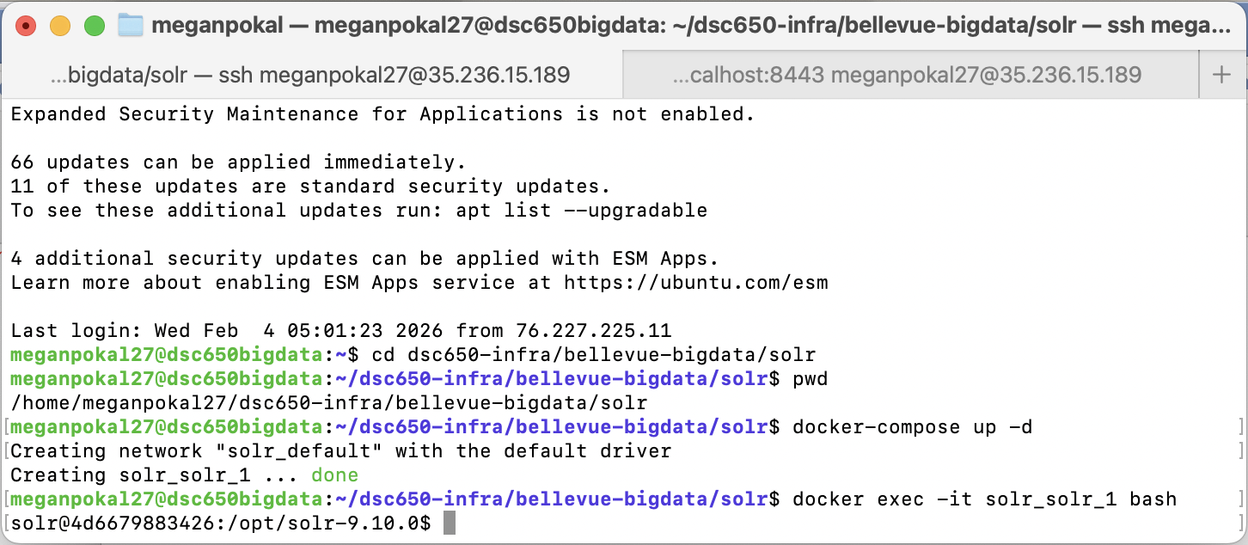

2. Creating a Solr Collection
In this section, you will create a Solr collection named mynewcollection. Solr collections are logical groupings of indexed data, and each collection is capable of being queried independently.
Exercise 1: Create a Solr collection named ‘mynewcollection’.
/opt/solr/bin/solr create -c mynewcollection
This command creates a new Solr collection named mynewcollection. It will be ready to index and store documents.
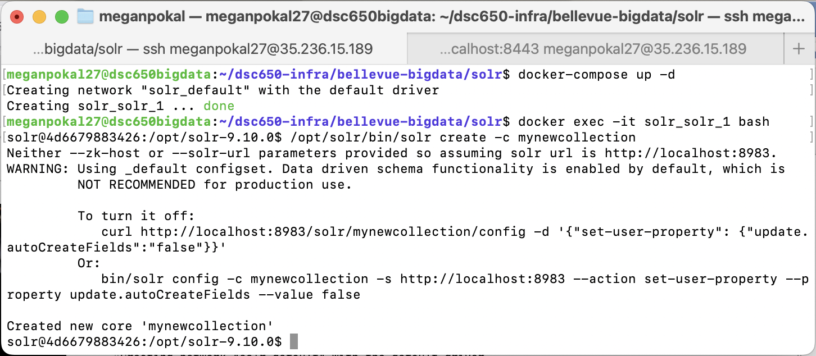

Exercise 2: Verify that ‘mynewcollection’ has been successfully created.
- Access Solr’s Web Interface at http://localhost:8983/solr/ and check for ‘mynewcollection’ under the “Core Selector” dropdown.

The “mynewcollection’ on Solr local host has been successfully created. http://localhost:8983/solr/#/mynewcollection/core-overview, and appears in the Solr Web interface dropdown. Being listed indicates that Solr has initialized the collection and is it ready to accept data.
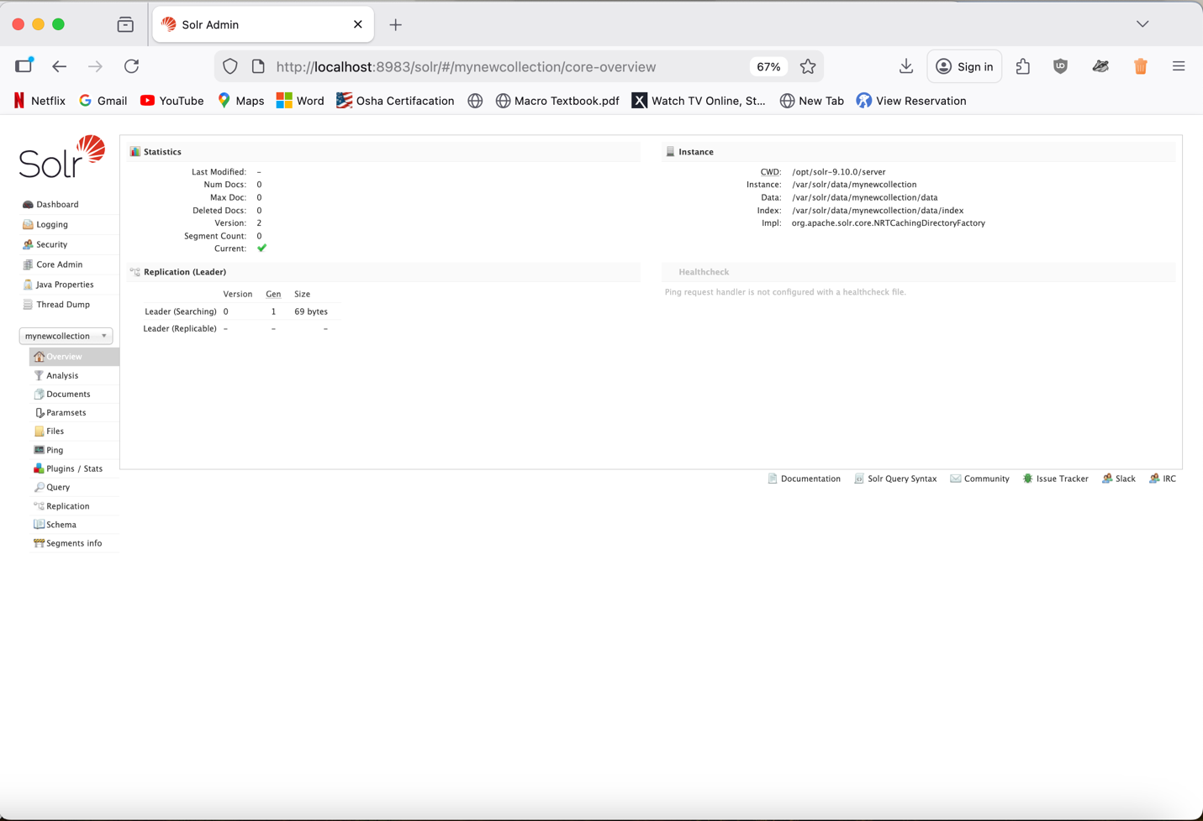

Objective 3 - Adding Data to the Collection:

1. Generating and Adding Data to the Collection
You will now generate sample data in JSON format and add it to the mynewcollection for indexing. This step allows you to see how Solr ingests structured data into its indexing engine.
For this exercise, create a json file called products.json using this commands:
echo '[
{"id":"1", "name":"Product A", "category":"Electronics", "price":"100"},
{"id":"2", "name":"Product B", "category":"Books", "price":"20"}
]' > /tmp/products.json
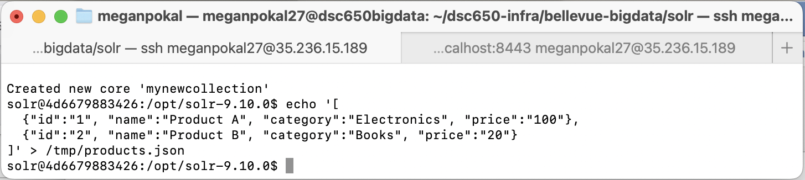
Exercise 3: Let’s add the generated data to our collection.
/opt/solr/bin/solr post -c mynewcollection /tmp/products.json
Above you added information and added it to a file called products.json. This file has been successfully added to into mynewcollection. This commend ingests the JSON data into mynewcollection.
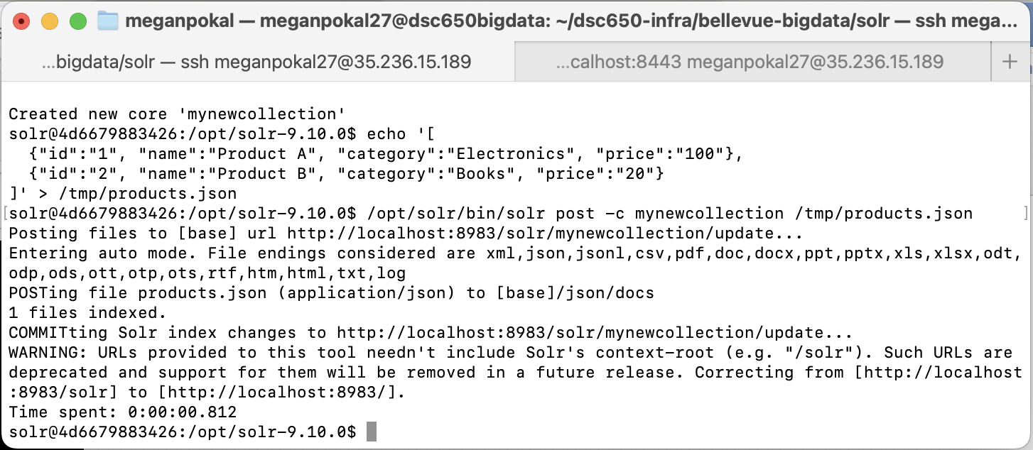
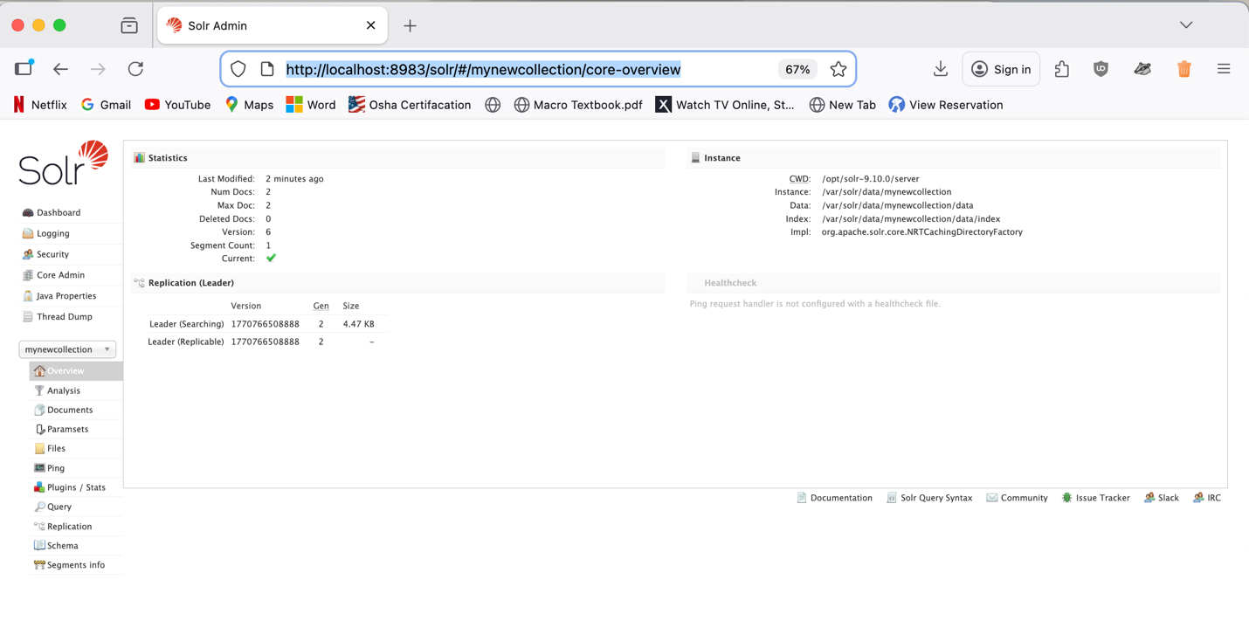
Objective 4 - Querying the Collection:

1. Querying the Collection
Now that the data has been ingested, you will perform queries on the mynewcollection using Solr’s command line query interface. This demonstrates how Solr processes and retrieves indexed data.
Exercise 4: Use Solr’s query interface to retrieve all documents from ‘mynewcollection’.
curl http://localhost:8983/solr/mynewcollection/select?q=*:*
This query shows all documents from mynewcollection. This confirms that the data was successfully put into Solr and is searchable. Q=*:* is a match all query.
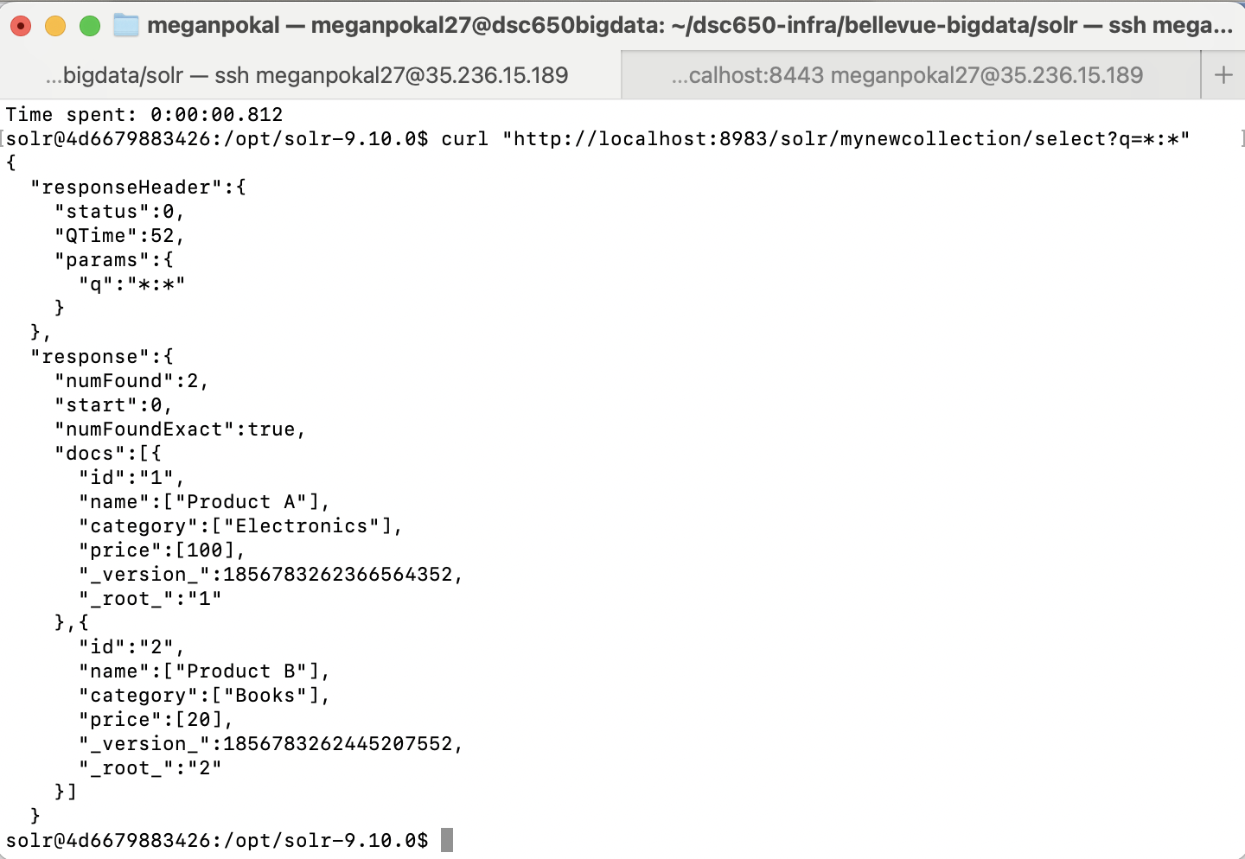
Exercise 5: Query for products in the ‘Electronics’ category.
curl http://localhost:8983/solr/mynewcollection/select?q=category:Electronics
This query shows documents from mynewcollection where the category field is Electronics. Showing only the products classified under Electronics. Solr can filter by specific field values.
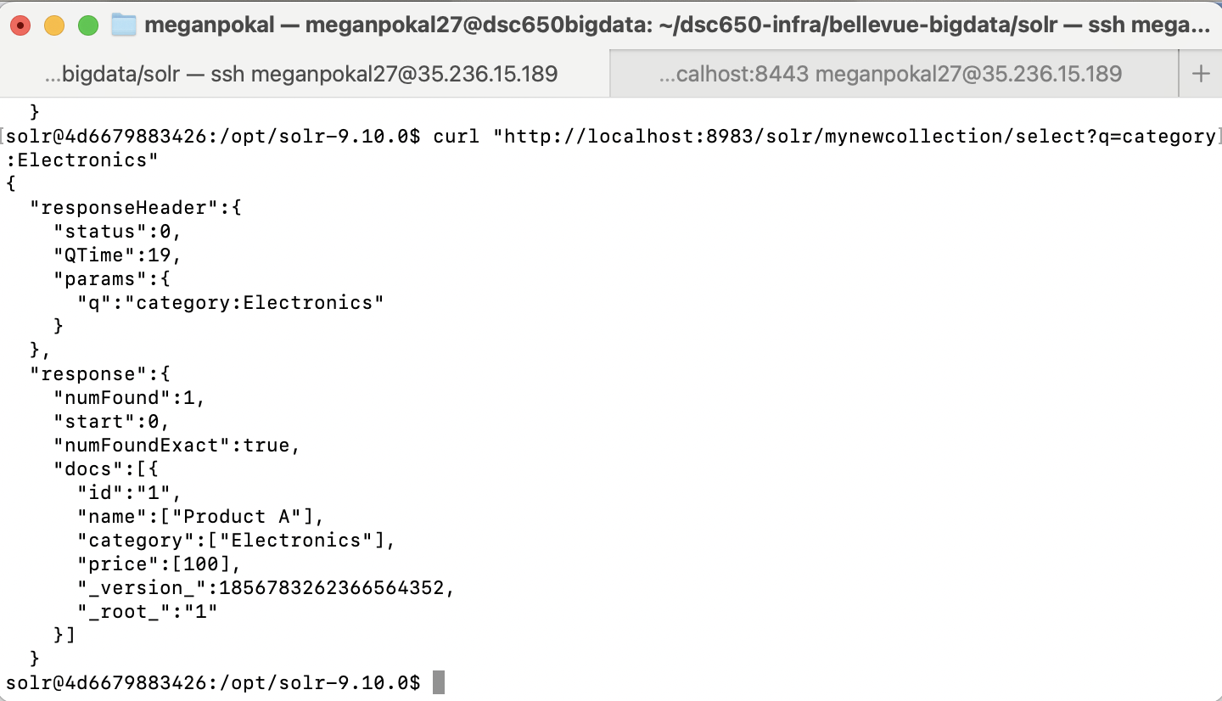

Objective 5 - Advanced Querying in the Solr Web Interface:

1. Advanced Querying in Solr Web Interface

Access the Solr Web Interface for querying:
Query ‘mynewcollection’ in Solr Web Interface:

Exercise 6: Run a faceted search on the id field to count how many documents are in your collection.
All the documents in mynewcollection. A facet_counts section shows each unique id value and how many documents are associated with it. This faceted search groups documents by id field and displays the count for each unique id. Showing how many documents exist in the collection and confirms that each document is indexed correctly.

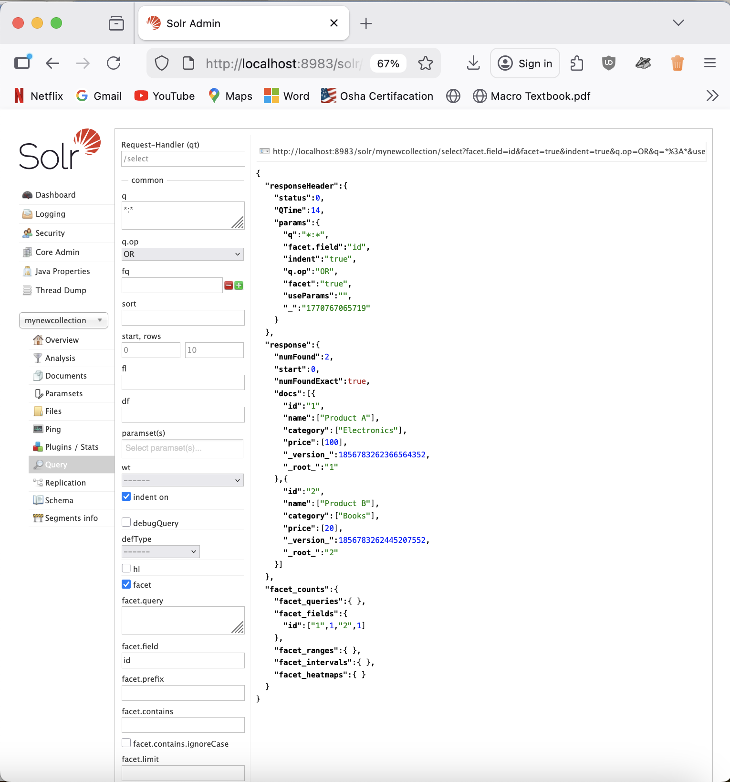
Exercise 7: Use the Web Interface to experiment further with various query parameters and filters.
Query 1: Sorting results by price
Sort: price asc
This query sorts all the documents by the price field in ascending order. The results show that Product B, price 20, appears before Product A, price 100, confirming that Solr successfully put them from lowest to highest price.
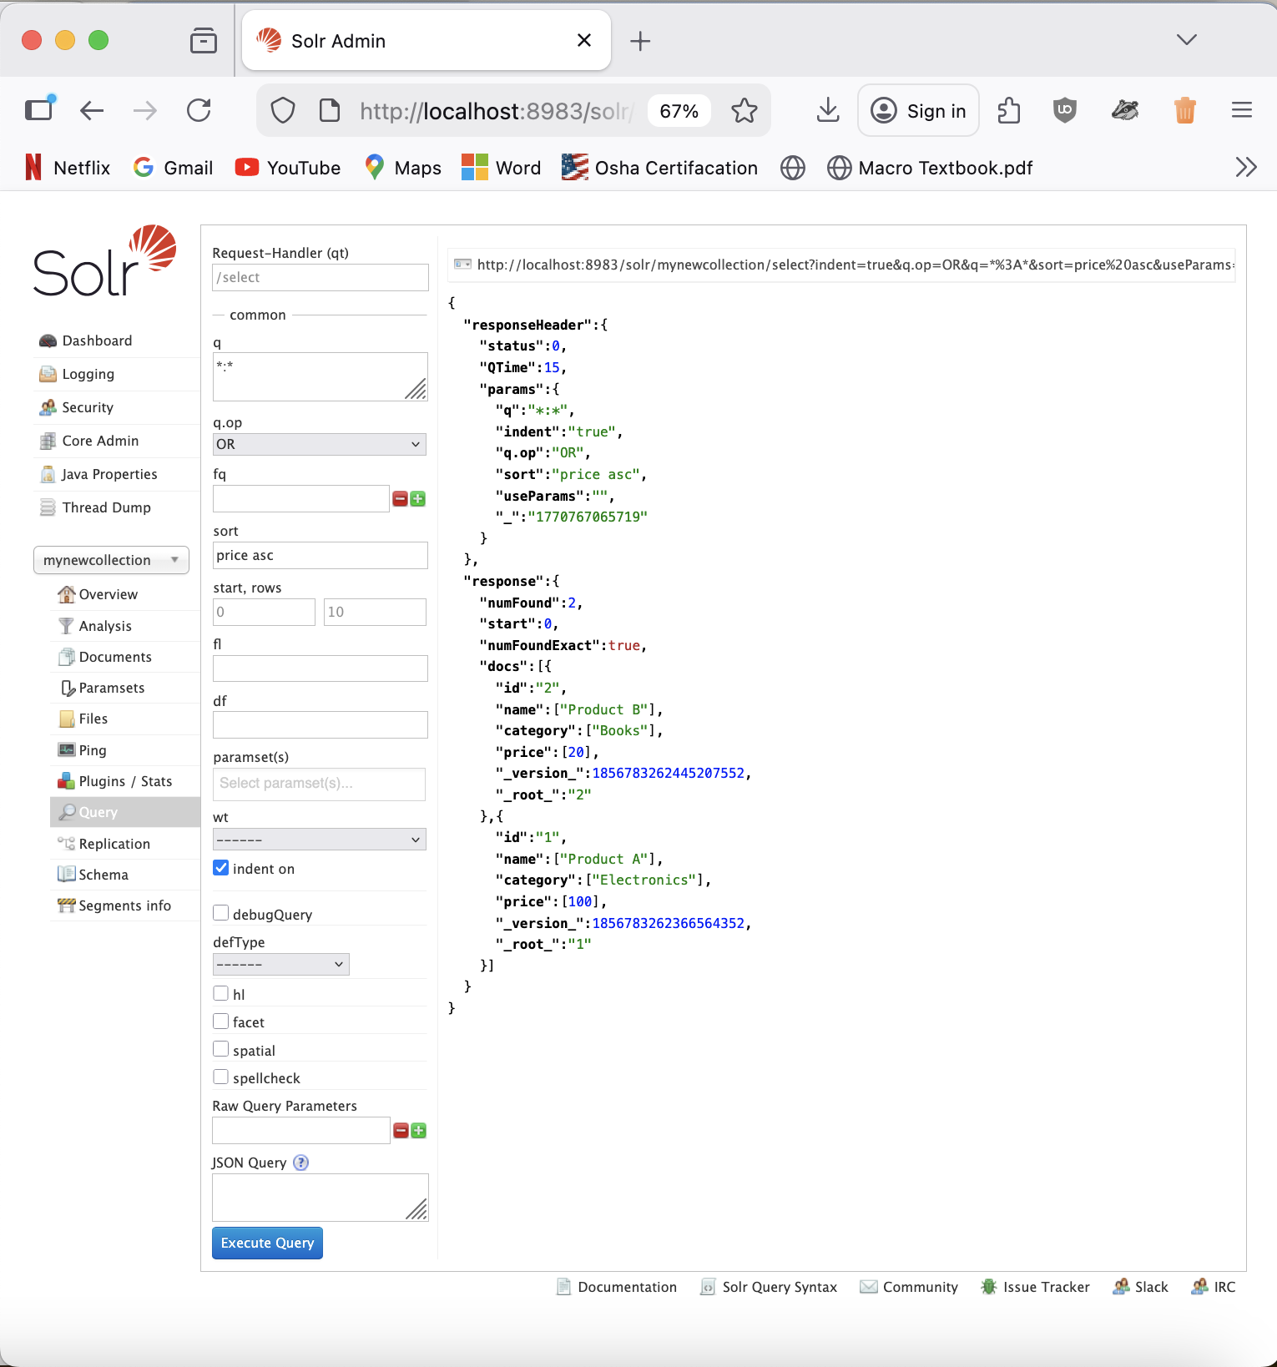

Query 2:
q: *:*
Start, Rows: 0, 5

This query limits the results to five documents at a time. Even though this collection only has two documents, it shows how Solr supports paging through large datasets by your desired results. This demonstrates pagination by using the rows 5 and start 0.
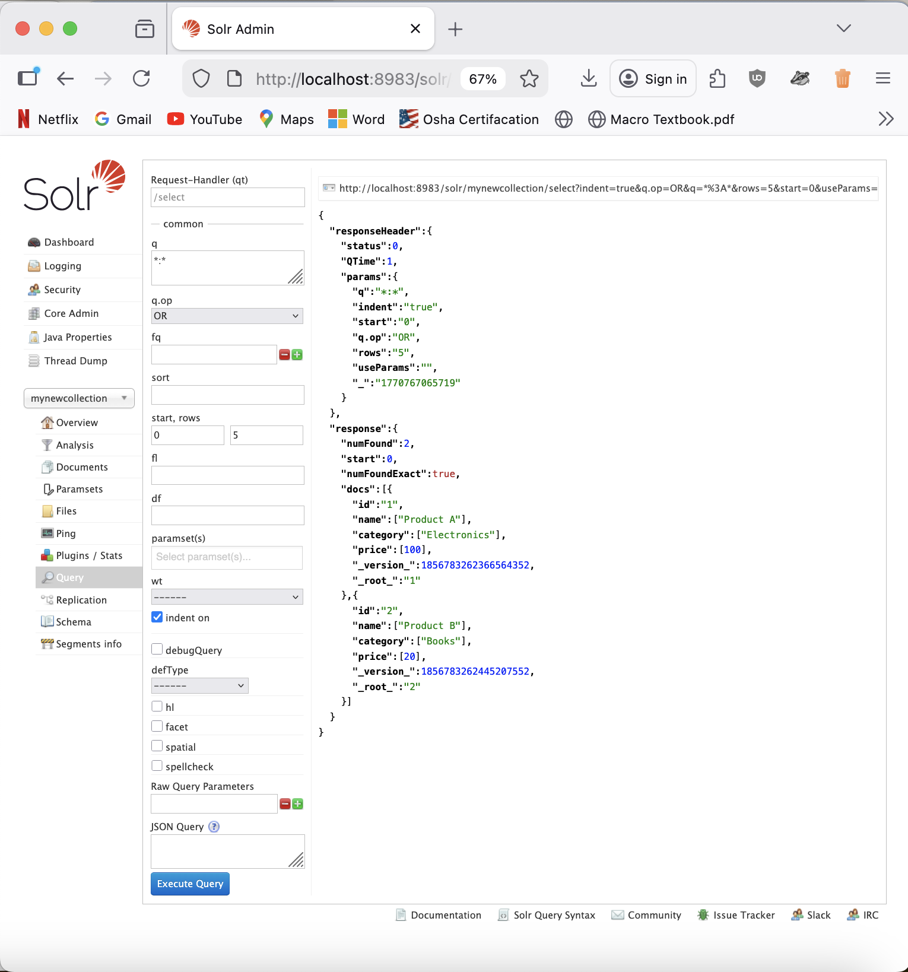

Objective 6 - Working with Custom JSON Data:

- Create a new collection

bin/solr create -c megancollection

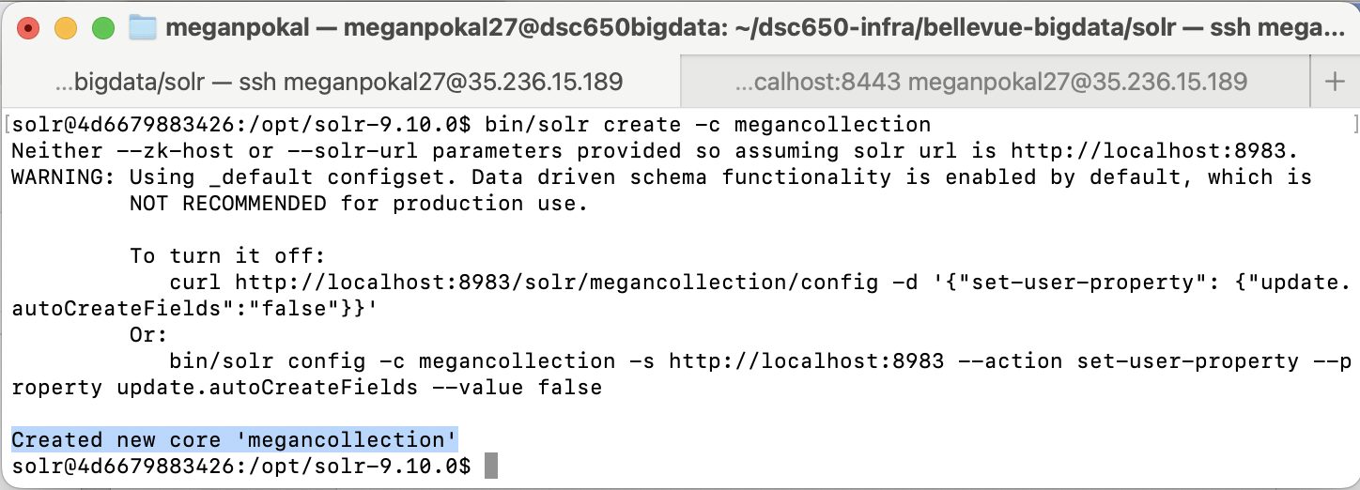

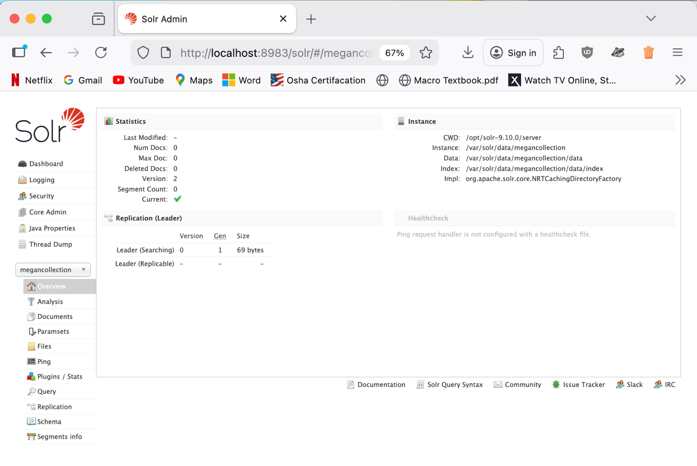

- Use JSON data from the web
Creating a json file.
Website: https://developers.squarespace.com/view-json-data

echo '[
{
"id": "1",
"collection_id": "5048fde7c4aa917cbd4d8e13",
"websiteId": "50295e80e4b096e761d7e4d3",
"enabled": true,
"starred": false,
"type": 1,
"ordering": 2,
"title": "Blog",
"navigationTitle": "Blog",
"urlId": "blog",
"itemCount": 2,
"updatedOn": 1454432700858,
"pageSize": 20,
"folder": false,
"dropdown": false,
"tags": ["tag1","pizza","coffee","snacks","tag2"],
"categories": ["category1","category2"],
"homepage": false,
"typeName": "blog",
"synchronizing": false,
"fullUrl": "/blog/",
"passwordProtected": false,
"typeLabel": "blog"
},
{
"id": "2",
"collection_id": "5048fde7c4aa917cbd4d8e13",
"websiteId": "50295e80e4b096e761d7e4d3",
"enabled": true,
"starred": true,
"type": 1,
"ordering": 3,
"title": "Food Blog",
"navigationTitle": "Food Blog",
"urlId": "food-blog",
"itemCount": 5,
"updatedOn": 1454432709999,
"pageSize": 20,
"folder": false,
"dropdown": false,
"tags": ["pizza","coffee"],
"categories": ["category2"],
"homepage": false,
"typeName": "blog",
"synchronizing": false,
"fullUrl": "/food-blog/",
"passwordProtected": false,
"typeLabel": "blog"
}
]' > /tmp/products.json

After finding this sample JSON dataset from the web, we have to create a json file called products.json using the command above. This will allow the information to be in the file products.json, in megancollection.

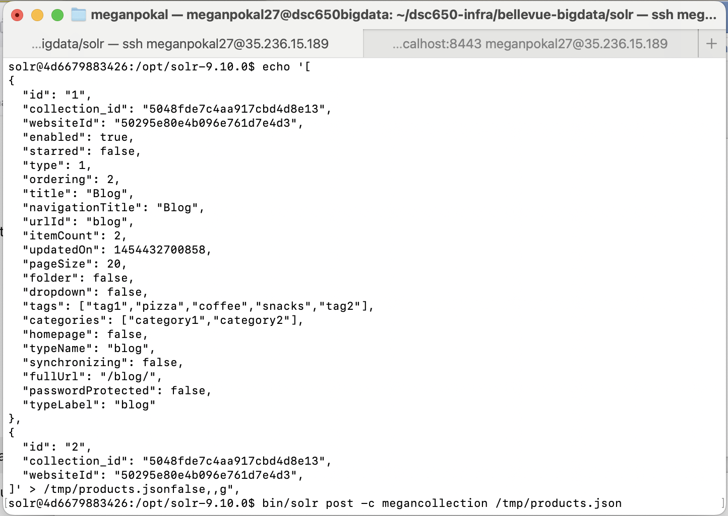

bin/solr post -c megancollection /tmp/products.json
Adding the generated data to the new collection.
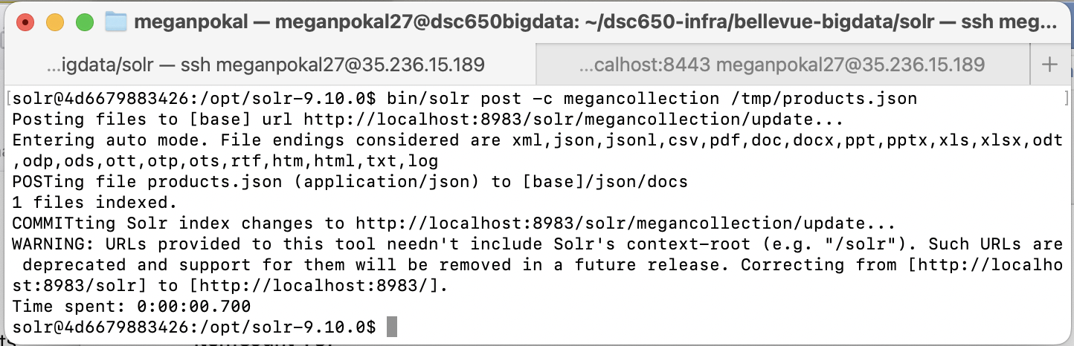

Query 1: to retrieve all documents from megancollection
curl http://localhost:8983/solr/megancollection/select?q=*:*
This query shows all documents from the megancollection using the match-all query. The results confirm that the JSON dataset was successfully indexed into Solr and the documents are searchable.
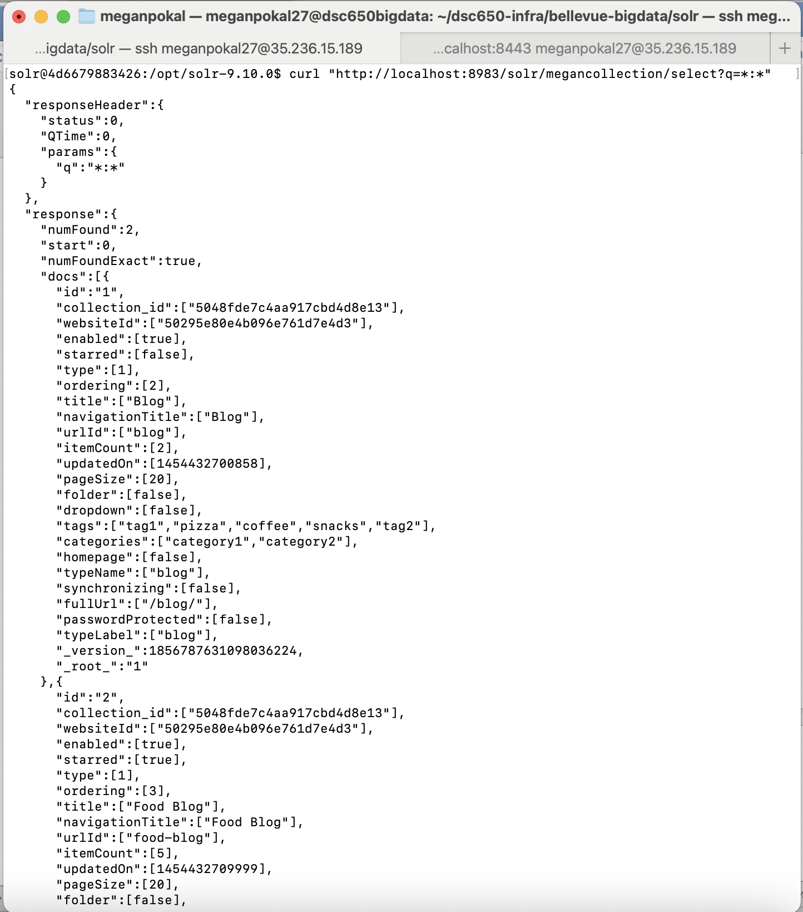

Query 2: Search by Tag Pizza
curl http://localhost:8983/solr/megancollection/select?q=tags:pizza

This query searches for documents containing the tag pizza. Solr successfully indexed the fields and can return documents based on specific tag values.
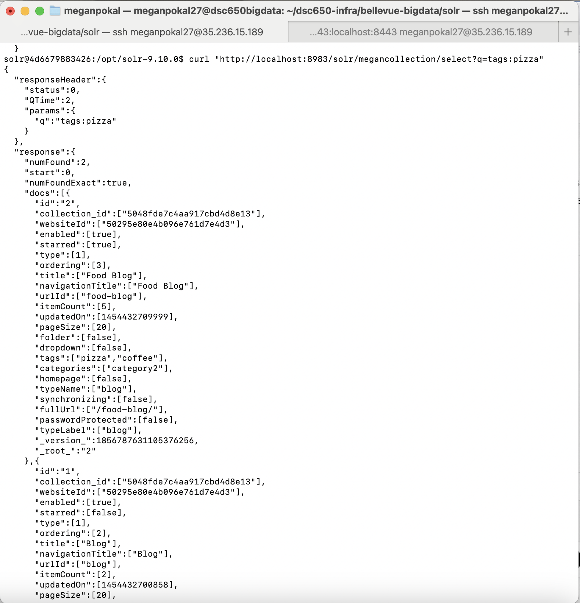

Query 3: Filter
curl http://localhost:8983/solr/megancollection/select?q=starred:true

This query shows only documents where the starred field is true. It also shows Solr ability to filter documents using Boolean field values.
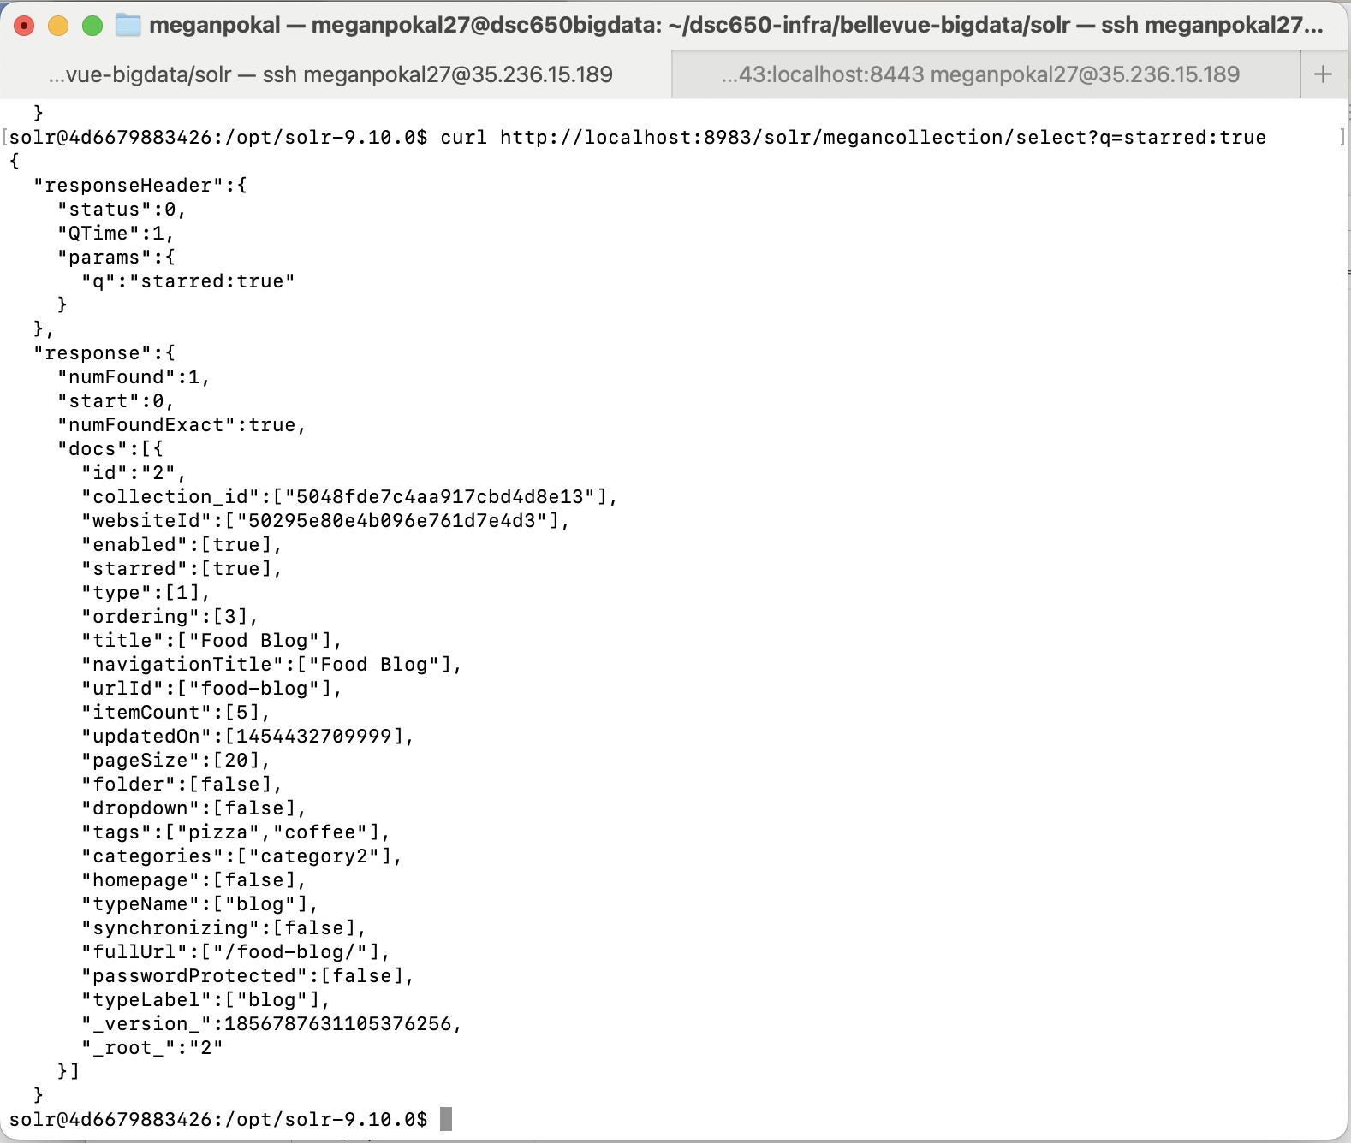

Query 4:
Q: tags: coffee
Start, Rows: 0, 5

This query searches for documents containing the tag “coffee”. Along with only looking at the first 5 rows.
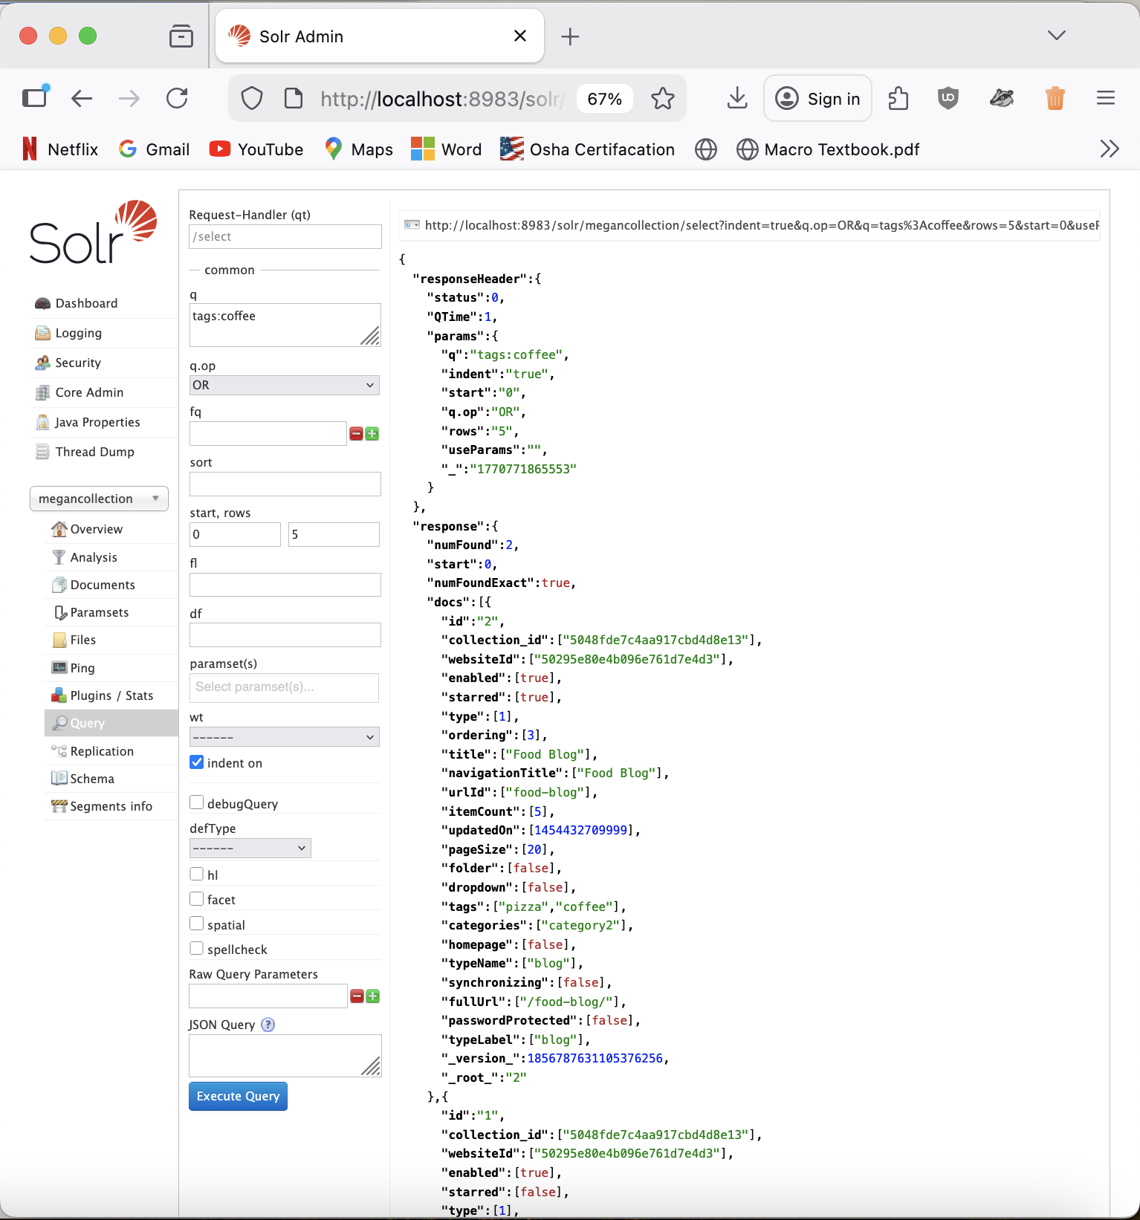

Deliverable 3:

It was interesting working with a different dataset, because the JSON dataset that I had found had a lot more information. So, when I was doing the query, it was a lot longer, and there were more options that I could choose between on what to look up in the data. Solr does nicely and neatly lay out all the information in the structured data, so you can easily read/access it. You can easily filter, sort, and perform faceted searches within the Solr web or within the terminal. Experimenting with the queries in both examples, like searching by tags, filtering by Boolean fields, and sorting by numeric fields, shows how Solr can simply lay all this information quickly and easily to read. After following the first example, it was pretty easy to replicate it with my own dataset.

